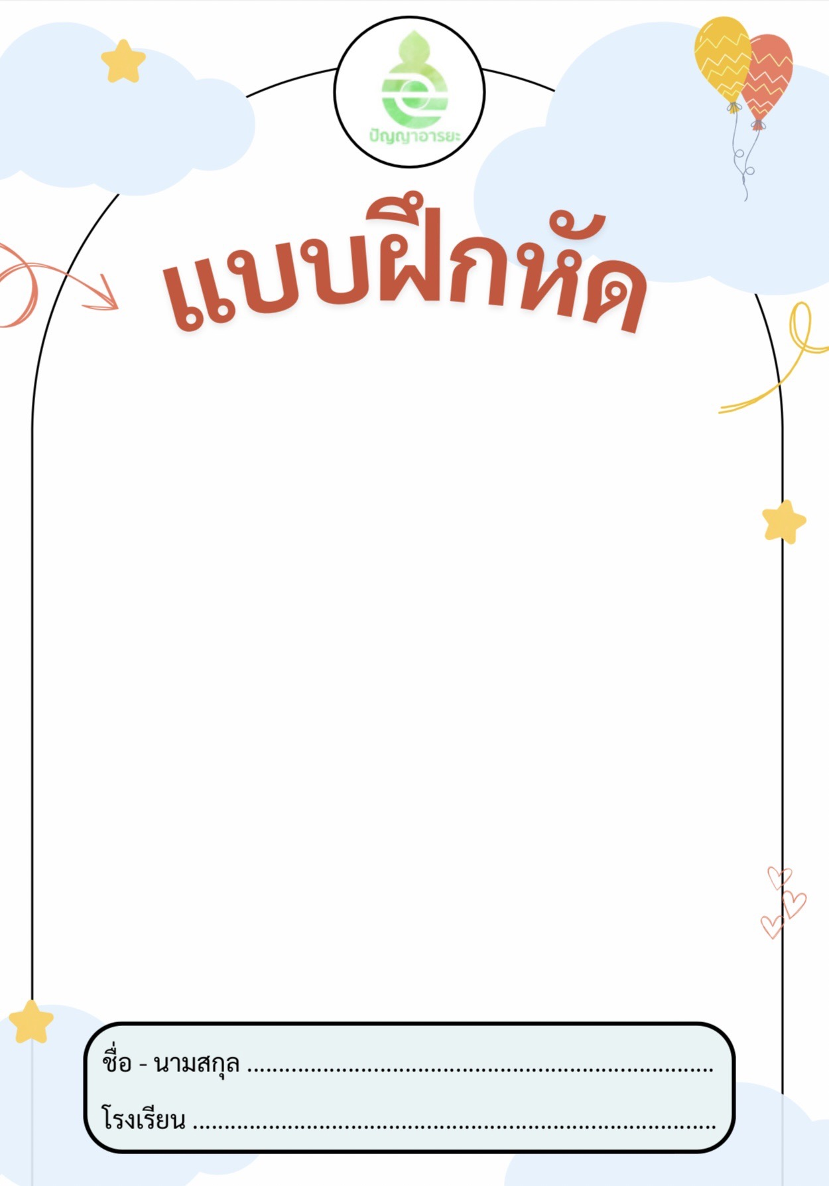

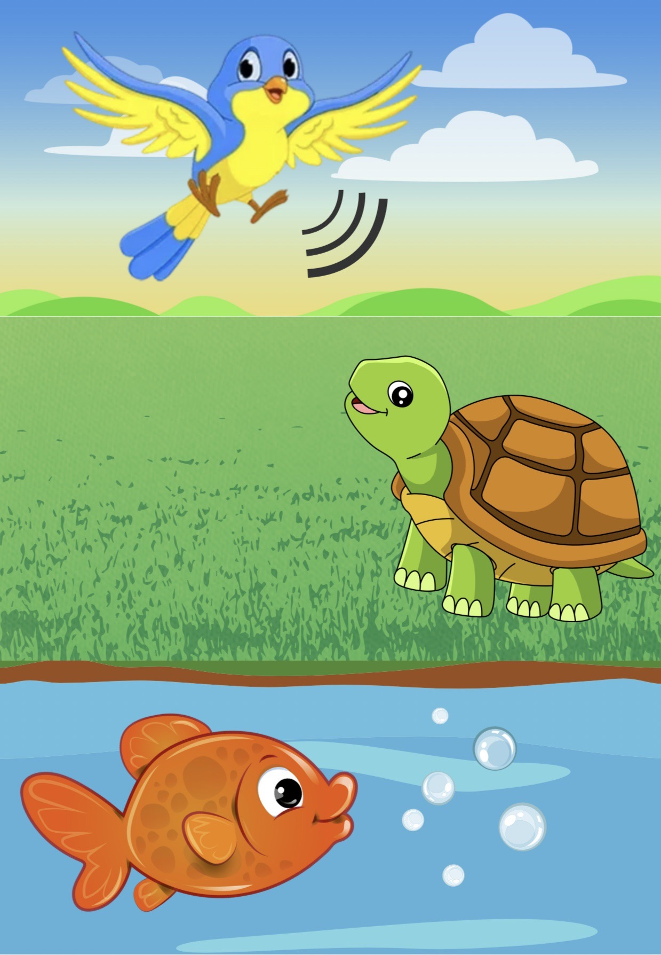

 **กิจกรรมที่ ๑** ทฤษฎีมุมมอง

* 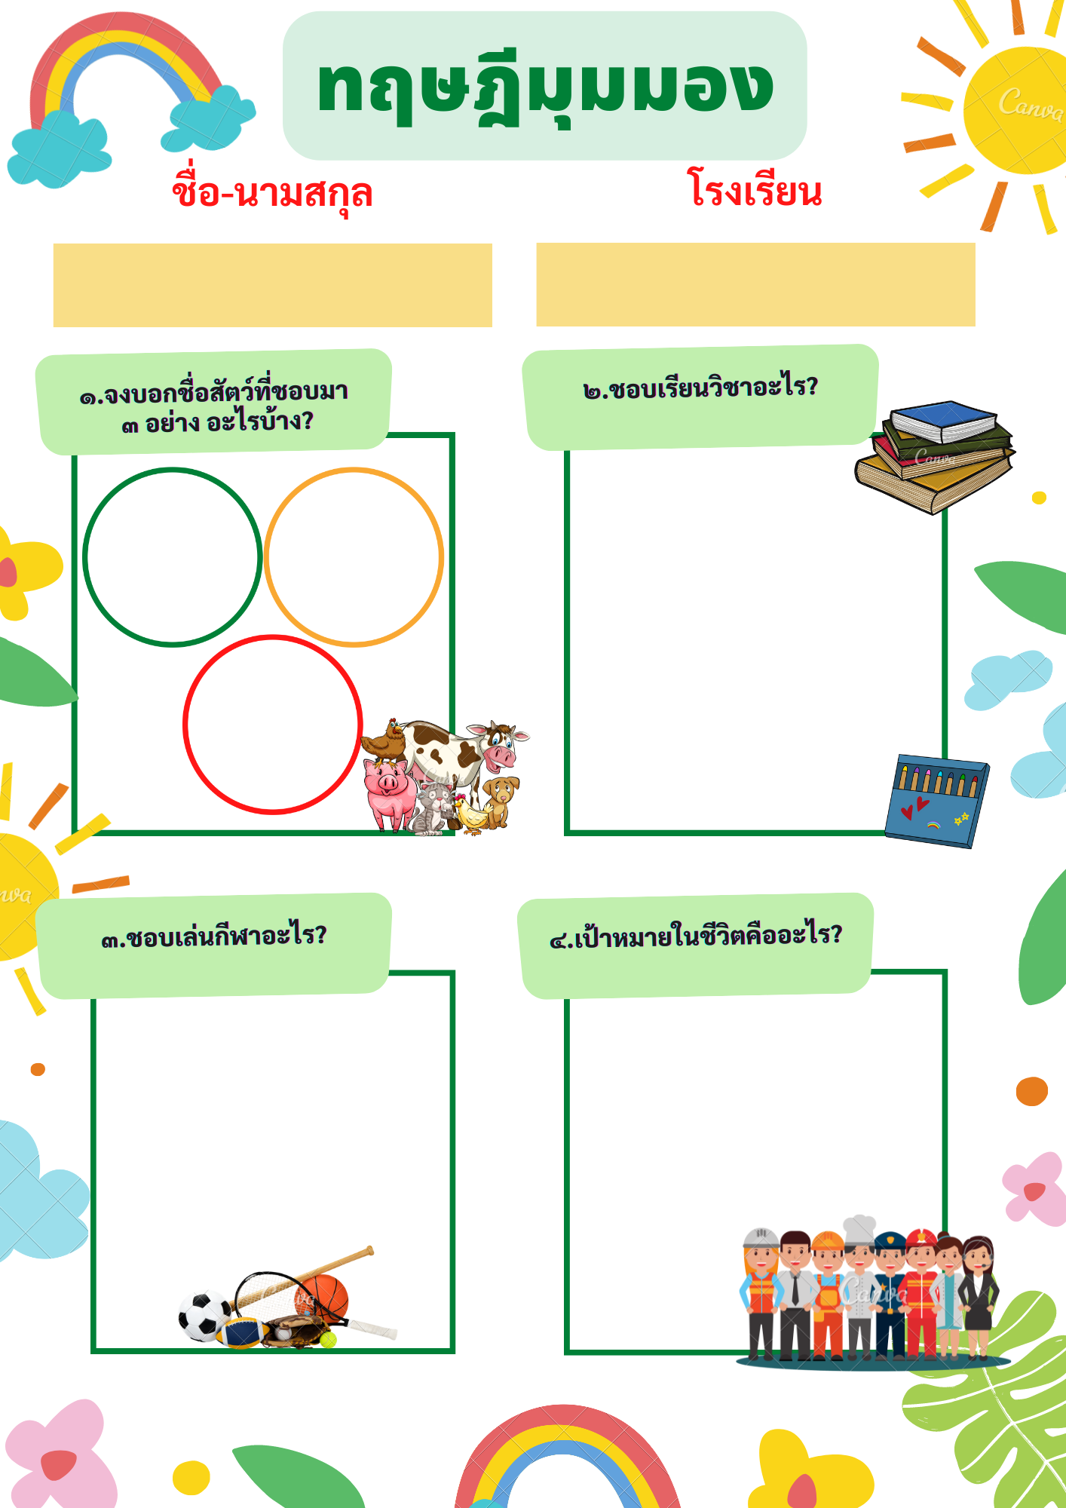

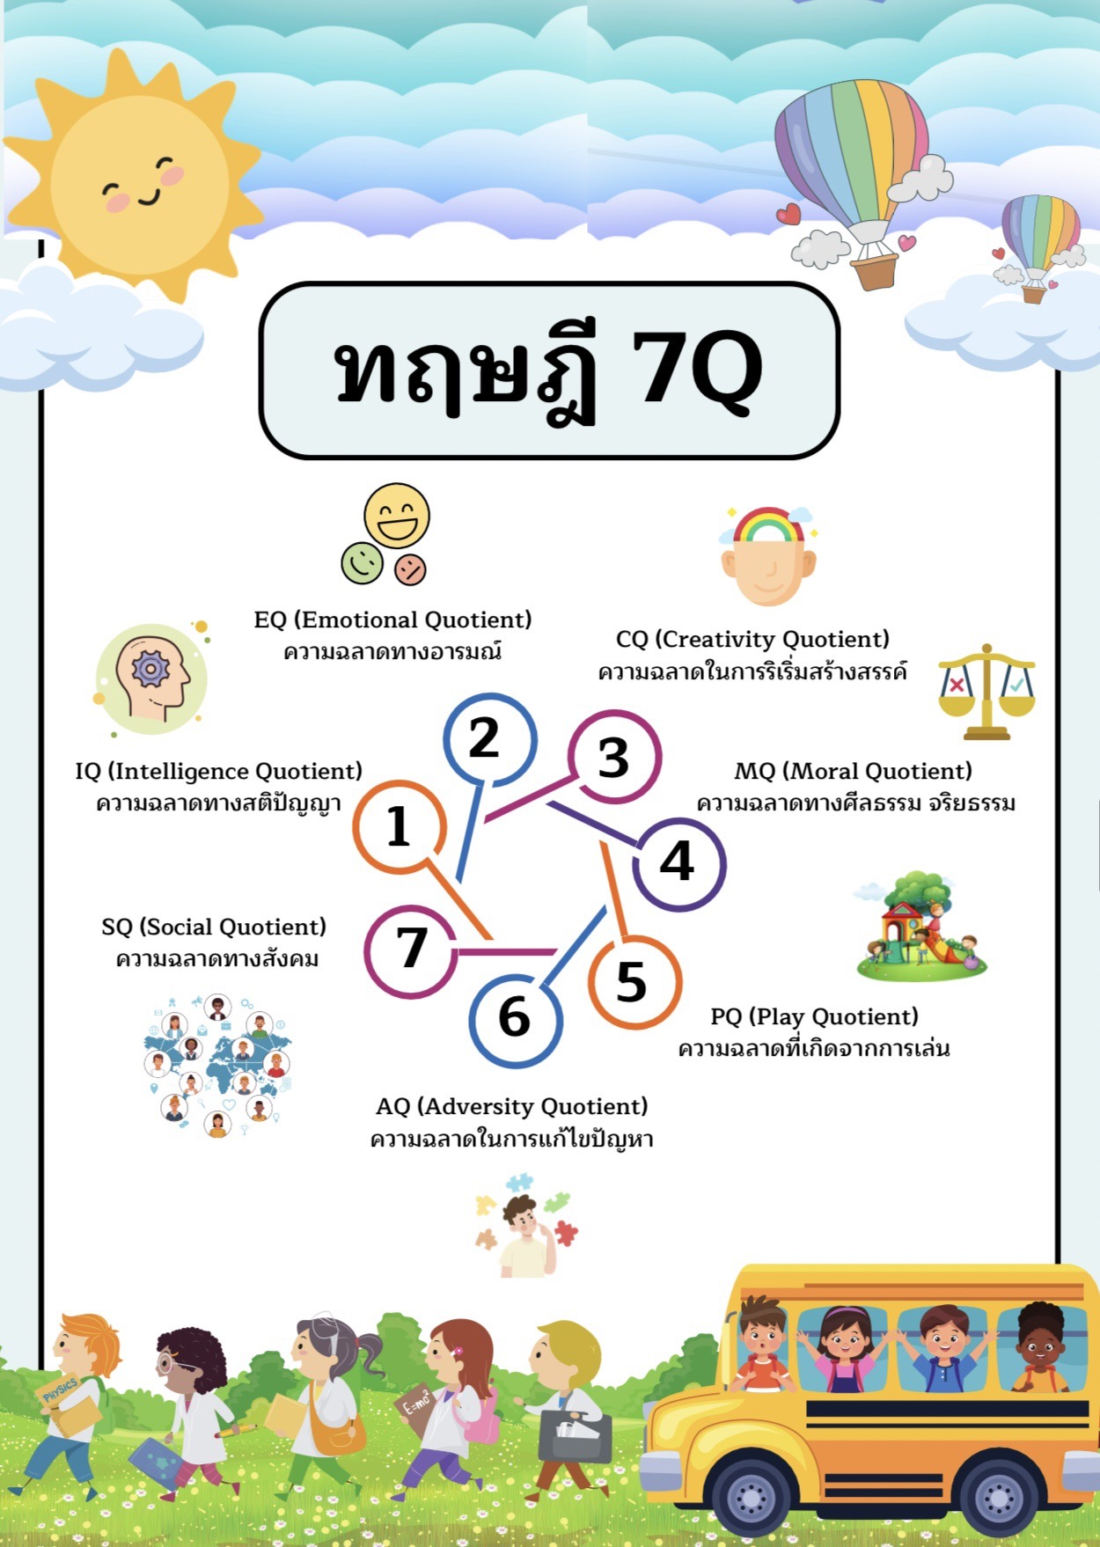

 **กิจกรรมที่ ๒ CQ(Creativity Quotient) “ความฉลาดในการริเริ่มสร้างสรรค์”**

**ชื่อ - นามสกุล.............................................................. โรงเรียน............................................................**

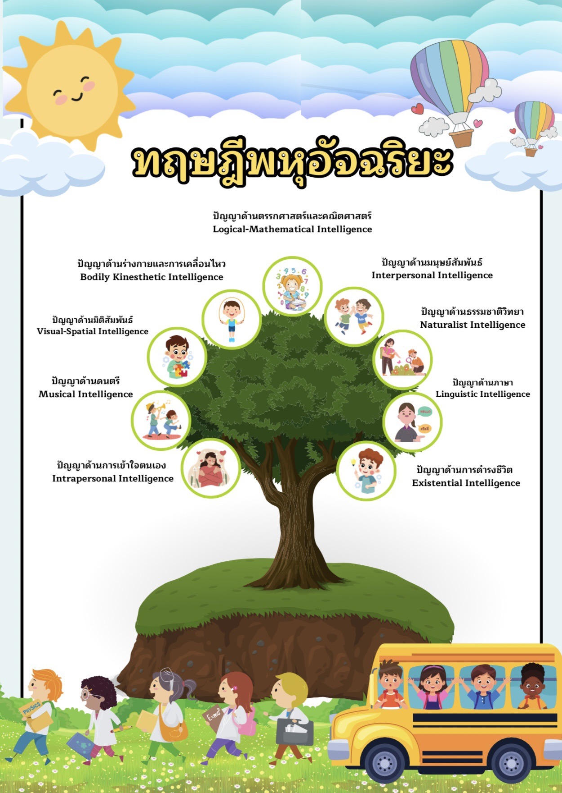

*  **กิจกรรมที่ ๓** ทฤษฎีพหุอัจฉริยะ

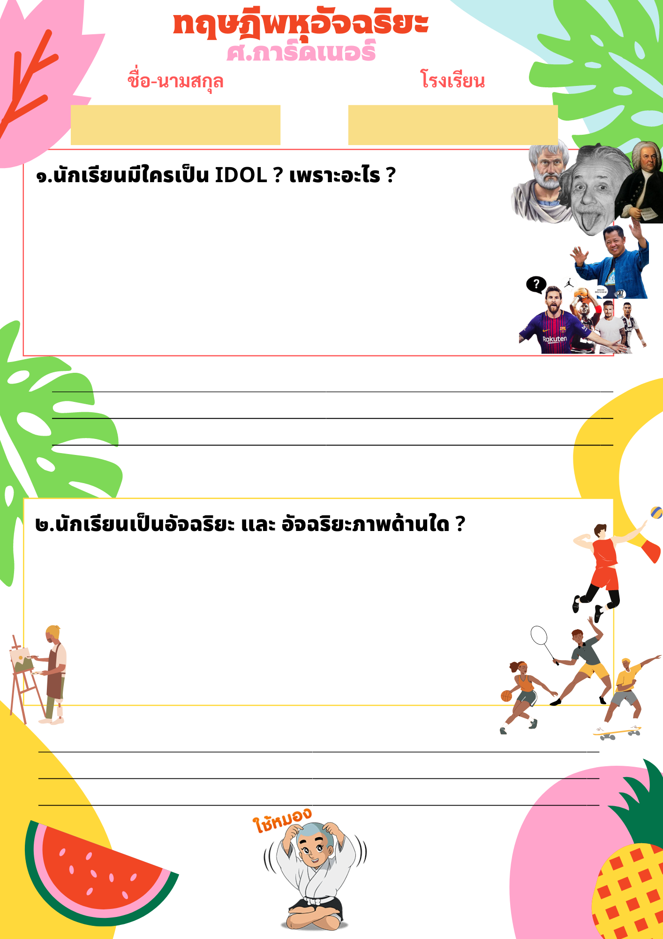

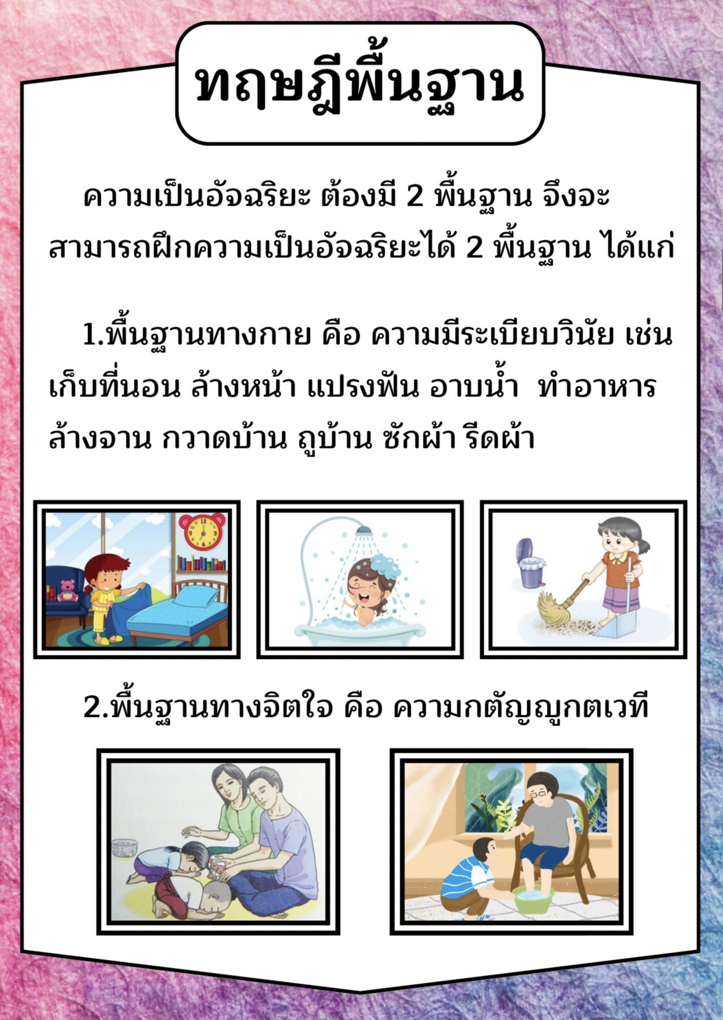

**กิจกรรม ๔ ครอบครัวสร้างสุข**

|  |  |  |  |  |  |  |
| --- | --- | --- | --- | --- | --- | --- |
| **ว/ด/ป** | **กิจกรรมครอบครัวสร้างสุข** | | | | | **หมายเหตุ** |
| **เก็บที่นอน** | **อาบน้ำ** | **ล้างถ้วยชาม** | **ซักผ้า/รีดผ้า** | **กวาดบ้าน** |
|  |  |  |  |  |  |  |
|  |  |  |  |  |  |  |
|  |  |  |  |  |  |  |
|  |  |  |  |  |  |  |
|  |  |  |  |  |  |  |
|  |  |  |  |  |  |  |
|  |  |  |  |  |  |  |
|  |  |  |  |  |  |  |
|  |  |  |  |  |  |  |
|  |  |  |  |  |  |  |
|  |  |  |  |  |  |  |
|  |  |  |  |  |  |  |
|  |  |  |  |  |  |  |
|  |  |  |  |  |  |  |
|  |  |  |  |  |  |  |
|  |  |  |  |  |  |  |
|  |  |  |  |  |  |  |
|  |  |  |  |  |  |  |
|  |  |  |  |  |  |  |
|  |  |  |  |  |  |  |
|  |  |  |  |  |  |  |
|  |  |  |  |  |  |  |
|  |  |  |  |  |  |  |
|  |  |  |  |  |  |  |
|  |  |  |  |  |  |  |
|  |  |  |  |  |  |  |
|  |  |  |  |  |  |  |
|  |  |  |  |  |  |  |
|  |  |  |  |  |  |  |
|  |  |  |  |  |  |  |
|  |  |  |  |  |  |  |

**ชื่อ - นามสกุล ......................................................... โรงเรียน ...............................................**

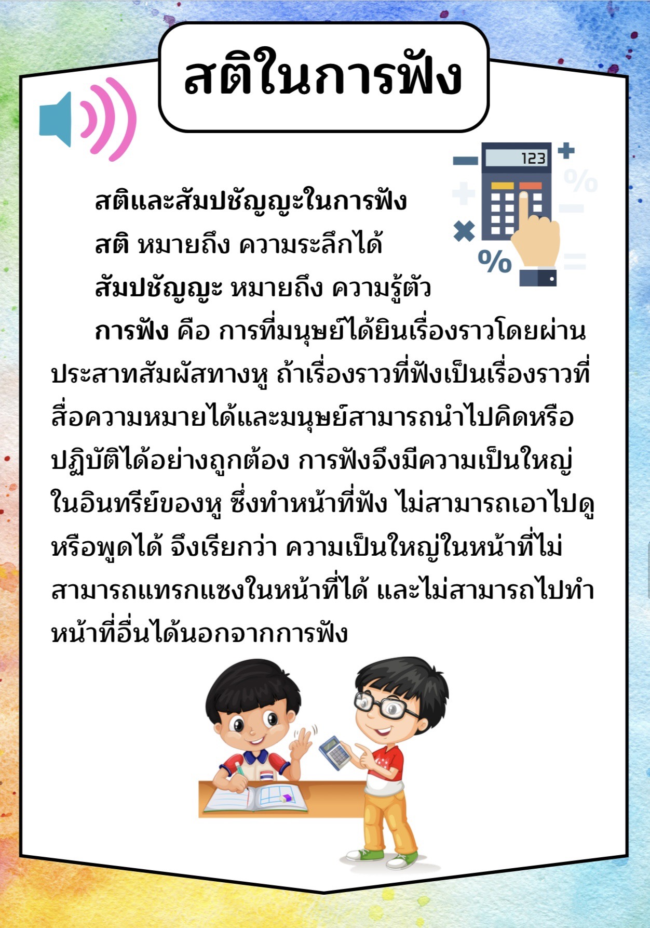

**กิจกรรมที่ ๕ ฝึกสติในการฟัง**

**หลักสูตรปัญญาอารยะ**

**ฝึกสติในการฟังให้อินทรีย์แก่กล้า**

**ชื่อ – นามสกุล โรงเรียน**

**…………………………………………………… ………………………………………………………**

1. ให้นักเรียนฝึกการฟังจากโจทย์การบวก ลบ ตัวเลขที่กำหนดให้ และให้นักเรียนฟังแล้วกดเครื่องคิดเลขตาม ให้ได้ผลลัพธ์ที่ถูกต้อง และให้ขีดเครื่องหมาย √, × ลงใน

๑.๑) ๒๑ + ๑๖ + ๒๕ - ๑๐ + ๓๘ + ๑๗ – ๒๐ + ๑๙ - ๕ + ๒๔ = **๑๒๕**

๑.๒) ๔๑ + ๖ + ๑๕ - ๔๑ + ๑๘ + ๗ – ๒๑ + ๑๓ - ๕๑ + ๑๔ + ๒๕ = **๒๖**

๑.๓) ๓๗ – ๒๕ + ๑๓ - ๑๑ + ๓๔ + ๒๖ + ๑๕ - ๑๘ + ๓๐ – ๒๑ = **๘๐**

๑.๔) ๔๑ + ๖ + ๑๕ - ๔๑ + ๑๘ + ๗– ๒๐ + ๑๙ - ๕ + ๒๔ + ๑๘= **๘๒**

๑.๕) ๑๗ + ๒๐ + ๑๙ - ๕ + ๒๔+ ๒๖ + ๑๕ - ๑๘ + ๓๐ – ๒๑ = **๑๐๗**

๑.๖) ๑๑ + ๓๔ + ๒๖ + ๑๕ – ๑๘ + ๖ + ๑๕+๑๙ - ๕ + ๑๔ - ๑๓ = **๑๐๔**

๑.๗) ๓๑ + ๑๔ + ๓๖ + ๕ – ๒๘ + ๒๑ + ๖๐ + ๑๒ – ๓๑ + ๕๐ = **๑๗๐**

๑.๘) ๑๕ + ๔๑ + ๑๘ + ๗ – ๒๑– ๒๐ + ๑๙ - ๕ + ๒๔ + ๒๐ – ๑๓ = **๘๕**

๑.๙) ๒๐ + ๑๙ - ๕ + ๒๔+ ๒๖ + ๑๕+ ๑๖ + ๒๕ - ๑๑ + ๓๕ – ๒๑ = **๑๔๓**

๑.๑๐) ๓๖ + ๑๕ - ๔๑ + ๑๘ + ๗ – ๒๑ + ๑๓+ ๖ + ๑๑ + ๑๙ - ๕ + ๑๔ = **๗๒**

1. ให้นักเรียนนำตัวเลขที่กำหนดให้ (+, -,×,÷) ให้ได้ผลลัพธ์ตามที่โจทย์กำหนดให้ โดยใช้ตัวเลขแต่ละตัวได้เพียงครั้งเดียวเท่านั้น

**5 9 7 6 4 = 12**

**9 4 3 5 8 = 17**

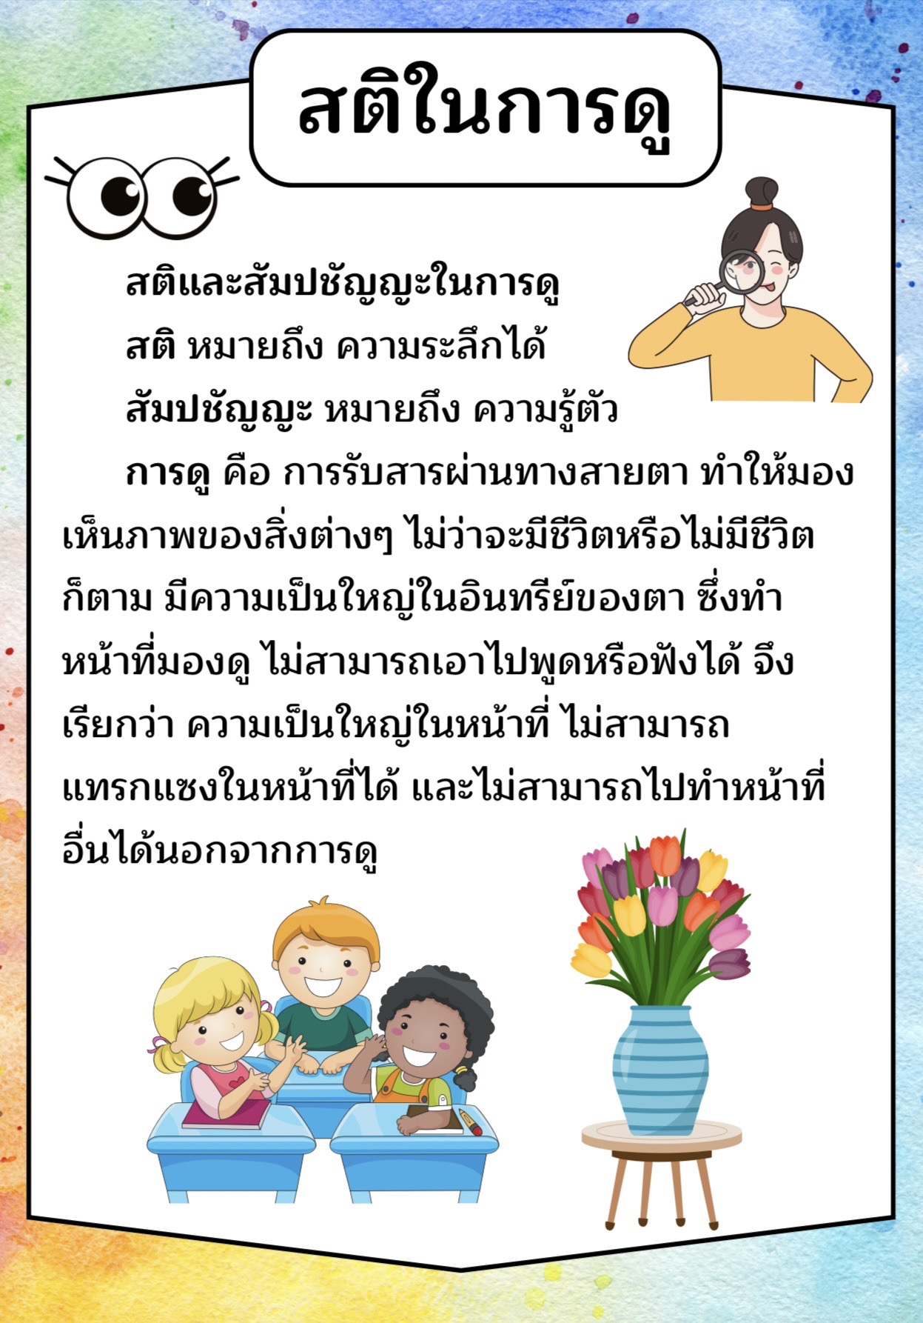

 **กิจกรรมที่ ๖ ฝึกความเป็นอัจฉริยภาพ**

**ชื่อ..................................................................... โรงเรียน............................................................**



**กิจกรรมที่ ๗ ฝึกสติในการดู**

ชื่อ - นามสกุล..............................................................โรงเรียน........................................................

1. จงเขียนอธิบายตามภาพที่เห็นเป็นข้อๆ ให้ได้มากที่สุด
2. .....................................................................................................
3. .....................................................................................................
4. .....................................................................................................
5. .....................................................................................................
6. .....................................................................................................
7. .....................................................................................................
8. .....................................................................................................
9. .....................................................................................................
10. .....................................................................................................
11. .....................................................................................................
12. .....................................................................................................
13. .....................................................................................................
14. .....................................................................................................
15. .....................................................................................................
16. .....................................................................................................
17. .....................................................................................................
18. .....................................................................................................
19. .....................................................................................................
20. .....................................................................................................
21. .....................................................................................................
22. .....................................................................................................
23. .....................................................................................................
24. .....................................................................................................
25. .....................................................................................................
26. .....................................................................................................
27. .....................................................................................................
28. .....................................................................................................
29. .....................................................................................................
30. .....................................................................................................
31. .....................................................................................................
32. .....................................................................................................
33. .....................................................................................................
34. .....................................................................................................
35. .....................................................................................................
36. .....................................................................................................
37. .....................................................................................................
38. .....................................................................................................
39. .....................................................................................................
40. .....................................................................................................
41. .....................................................................................................
42. .....................................................................................................
43. .....................................................................................................
44. .....................................................................................................
45. .....................................................................................................
46. .....................................................................................................
47. .....................................................................................................
48. .....................................................................................................
49. .....................................................................................................
50. .....................................................................................................
51. .....................................................................................................

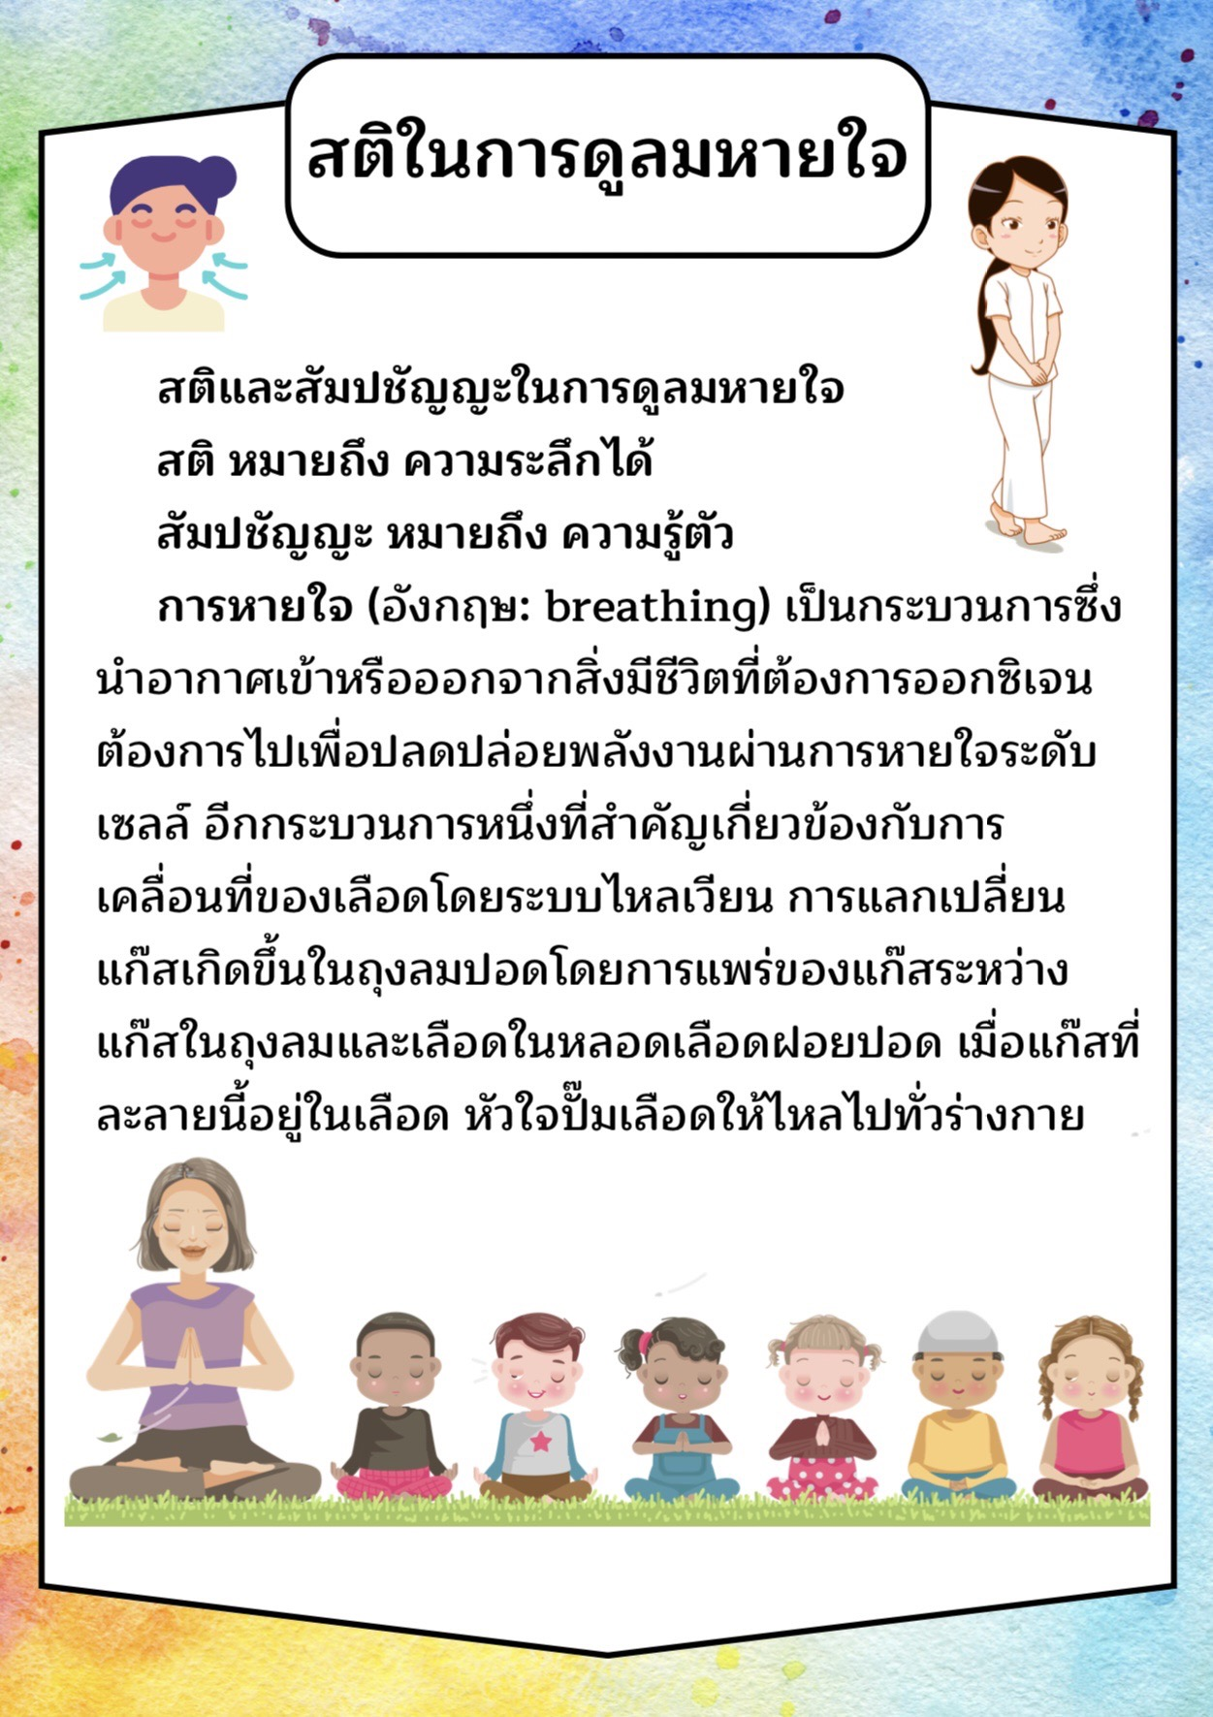

 **กิจกรรมที่ ๘ ฝึกสติในการดูลมหายใจ**

ชื่อ - นามสกุล................................ ..............................โรงเรียน........................................................

|  |  |  |  |
| --- | --- | --- | --- |
| **ลำดับที่** | **วัน/เดือน/ปี** | **สถิติของสมาธิ** | **หมายเหตุ** |
|  |  |  |  |
|  |  |  |  |
|  |  |  |  |
|  |  |  |  |
|  |  |  |  |
|  |  |  |  |
|  |  |  |  |
|  |  |  |  |
|  |  |  |  |
|  |  |  |  |
|  |  |  |  |
|  |  |  |  |
|  |  |  |  |
|  |  |  |  |
|  |  |  |  |
|  |  |  |  |
|  |  |  |  |
|  |  |  |  |
|  |  |  |  |
|  |  |  |  |
|  |  |  |  |
|  |  |  |  |
|  |  |  |  |
|  |  |  |  |

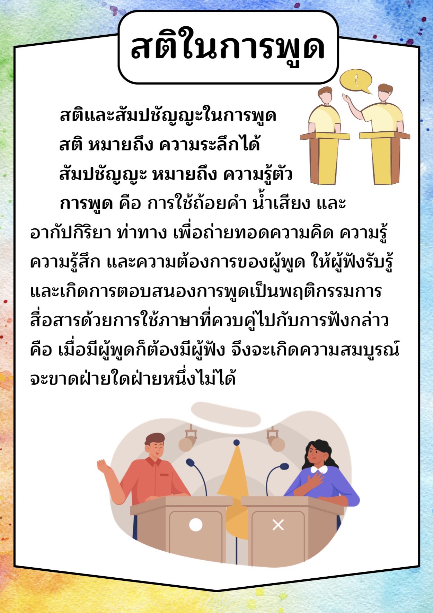

 **กิจกรรมที่ ๙ ฝึกสติในการพูด**

ชื่อ - นามสกุล..............................................................โรงเรียน........................................................

1. จงเขียนอธิบายเหตุผล ข้อดี และ ข้อเสีย ตามญัตติที่กำหนดให้

**ญัตติ ที่ ๑ การโต้วาที**

**จดดีกว่าจำ หรือ จำดีกว่าจด**

ข้อดีการจด ข้อเสียการจด

....................................................................................... ..........................................................................

....................................................................................... ..........................................................................

....................................................................................... ..........................................................................

....................................................................................... ..........................................................................

....................................................................................... .......................................................................... ....................................................................................... ..........................................................................

ข้อดีการจำ ข้อเสียการจำ

....................................................................................... ..........................................................................

....................................................................................... ..........................................................................

....................................................................................... ..........................................................................

....................................................................................... ..........................................................................

....................................................................................... .......................................................................... ....................................................................................... ..........................................................................

....................................................................................... ..........................................................................

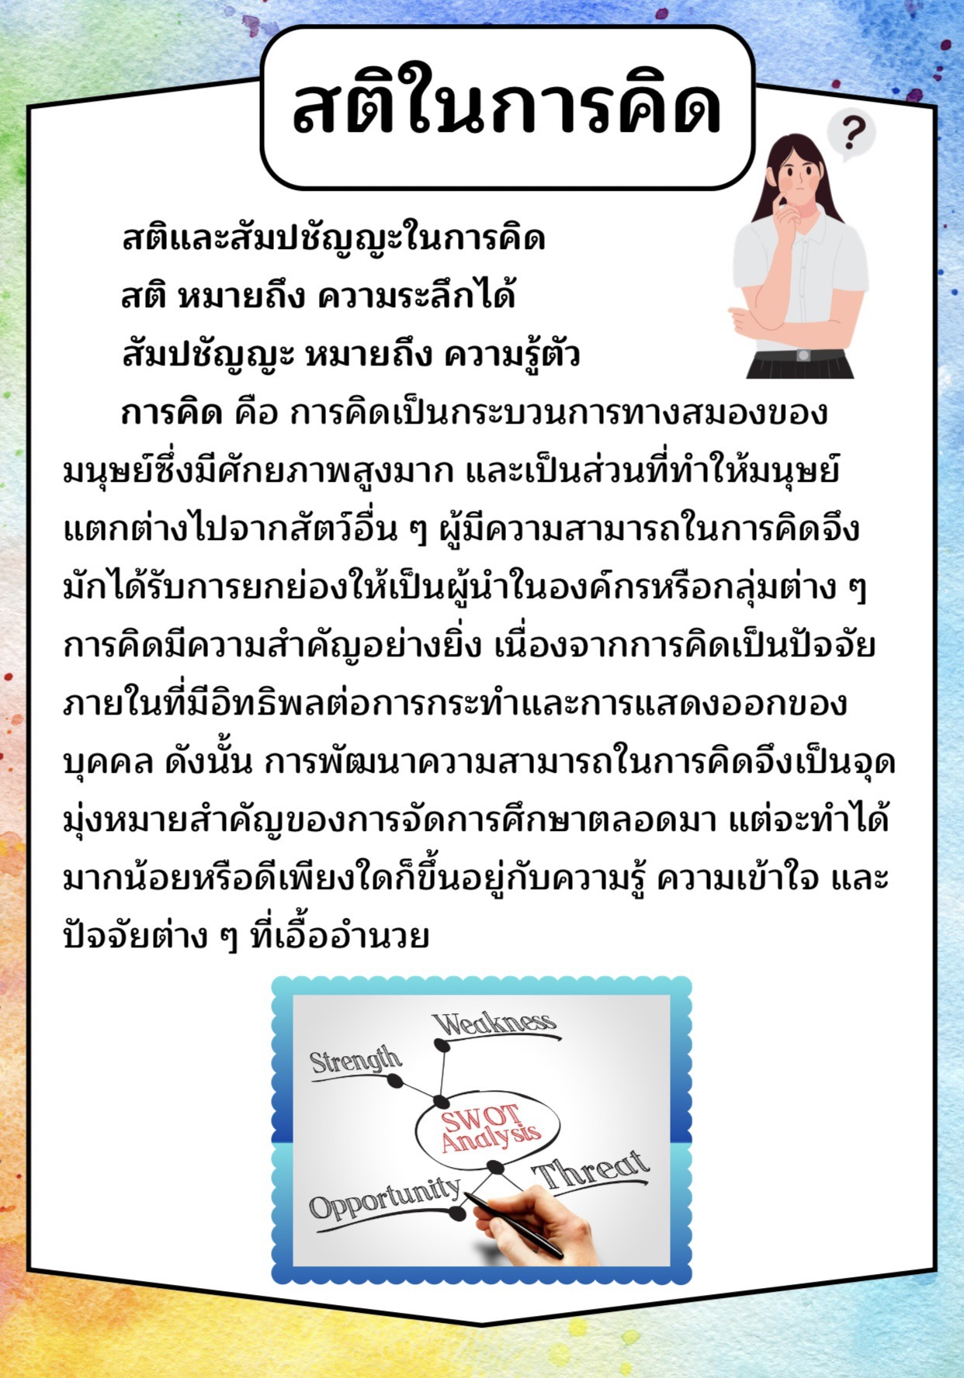

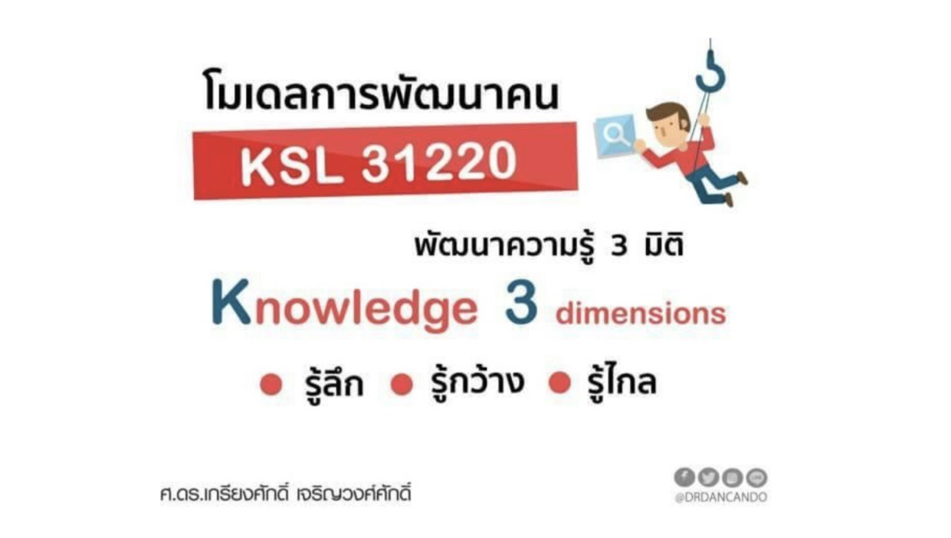

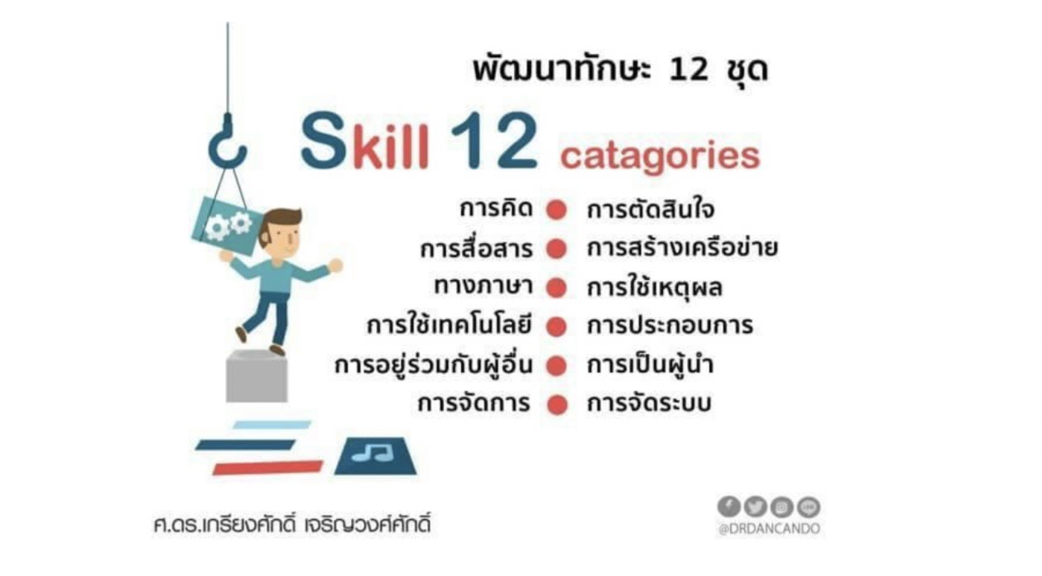

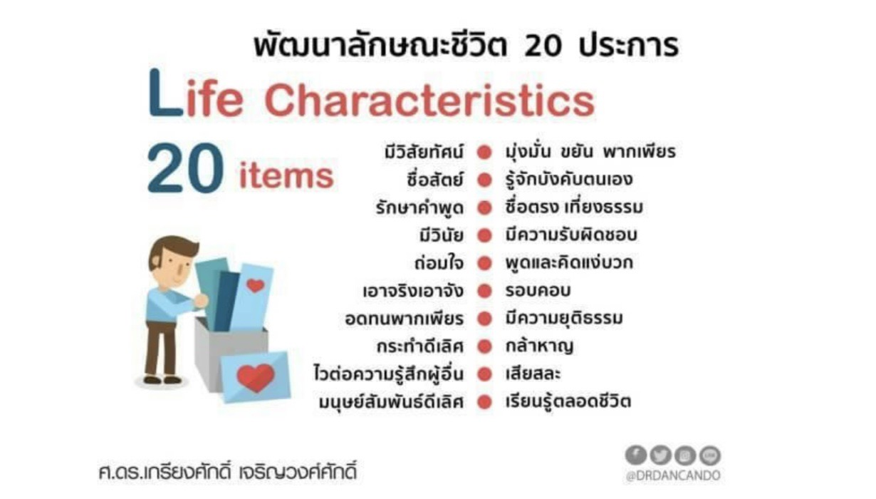

z  **กิจกรรมที่ ๑๐** โมเดลการพัฒนาคน KSL 31220 **วิเคราะห์ตนเอง**

ชั้น..................................................................................................................................................

|  |  |
| --- | --- |
| S  Strength  จุดแข็ง | W  Weakness  จุดอ่อน |
| ..........................................................................................  .........................................................................................  .........................................................................................  .........................................................................................  .........................................................................................  ..........................................................................................  .........................................................................................  .........................................................................................  ......................................................................................... | ..........................................................................................  .........................................................................................  .........................................................................................  .........................................................................................  .........................................................................................  ..........................................................................................  .........................................................................................  .........................................................................................  ......................................................................................... |
| O  Opportunity  โอกาส | T  Threat  อุปสรรค |
| ..........................................................................................  .........................................................................................  .........................................................................................  .........................................................................................  .........................................................................................  ..........................................................................................  .........................................................................................  .........................................................................................  ......................................................................................... | .......................................................................................  .......................................................................................  .......................................................................................  .......................................................................................  .......................................................................................  .......................................................................................  .......................................................................................  .....................................................................................  ...................................................................................... |

โรงเรียน..........................................................................................................................................

 **กิจกรรมที่ ๑๑** โมเดลการพัฒนาคน KSL 31220 **วิเคราะห์โรงเรียน**

ชั้น................................................................................................................................................

|  |  |
| --- | --- |
| S  Strength  จุดแข็ง | W  Weakness  จุดอ่อน |
| ..........................................................................................  .........................................................................................  .........................................................................................  .........................................................................................  .........................................................................................  ..........................................................................................  .........................................................................................  .........................................................................................  ......................................................................................... | ..........................................................................................  .........................................................................................  .........................................................................................  .........................................................................................  .........................................................................................  ..........................................................................................  .........................................................................................  .........................................................................................  ......................................................................................... |
| O  Opportunity  โอกาส | T  Threat  อุปสรรค |
| ..........................................................................................  .........................................................................................  .........................................................................................  .........................................................................................  .........................................................................................  ..........................................................................................  .........................................................................................  .........................................................................................  ......................................................................................... | .......................................................................................  .......................................................................................  .......................................................................................  .......................................................................................  .......................................................................................  .......................................................................................  .......................................................................................  .....................................................................................  ...................................................................................... |

โรงเรียน.......................................................................................................................................

 **หลักสูตรธรรมศึกษาชั้นตรี ระดับประถมศึกษา**

**กิจกรรมที่ ๑ วิชาพุทธประวัติ** **ผังมโนทัศน์ (Mind Map)**

คำสั่ง: ให้นักเรียนวาดแผนที่และแผนผังความคิดเพื่อแสดงความเชื่อมโยง

ชื่อ - นามสกุล .................................................................... โรงเรียน .......................................................................

 **หลักสูตรธรรมศึกษาชั้นตรี ระดับประถมศึกษา**

**กิจกรรมที่ ๒ วิชาธรรม** **ผังมโนทัศน์ (Mind Map)**

คำสั่ง: ให้นักเรียนวาดแผนที่ความคิดเพื่อแสดงความเชื่อมโยงธรรมหมวด ๒-๕

ชื่อ - นามสกุล .................................................................... โรงเรียน .......................................................................

**หลักสูตรธรรมศึกษาชั้นตรี ระดับประถมศึกษา**

**กิจกรรมที่ ๓ วิชาเบญจศีลเบญจธรรม** **ตัวชี้วัดภาวะคุณธรรม**

คำสั่ง: ให้นักเรียนกรอกข้อมูลตามจริงลงในแบบฟอร์ม

|  |  |  |  |  |
| --- | --- | --- | --- | --- |
| **ศีล**  **ข้อที่** | **ใจความแห่งศีล** | **ทำได้**  **(๒๐)** | **ทำไม่ได้**  **(๐)** | **หมายเหตุ** |
|  | ....................................................................................................  ....................................................................................................  ....................................................................................................  .................................................................................................... |  |  |  |
|  | ....................................................................................................  ....................................................................................................  ....................................................................................................  .................................................................................................... |  |  |  |
|  | ....................................................................................................  ....................................................................................................  ....................................................................................................  .................................................................................................... |  |  |  |
|  | ....................................................................................................  ....................................................................................................  ....................................................................................................  .................................................................................................... |  |  |  |
|  | ....................................................................................................  ....................................................................................................  ....................................................................................................  .................................................................................................... |  |  |  |
| **รวม** | |  |  |  |

 **หลักสูตรธรรมศึกษาชั้นตรี ระดับประถมศึกษา**

**กิจกรรมที่ ๔ วิชากระทู้ธรรม** **โครงสร้างกระทู้**

คำสั่ง: ให้นักเรียนเขียนโครงสร้างรูปแบบการเขียนเรียงความกระทู้ธรรมชั้นตรี

ชื่อ - นามสกุล .................................................................... โรงเรียน .......................................................................

 **หลักสูตรไตรภาวะ (ภาวะผู้นำ ภาวะผู้บริหาร ภาวะคุณธรรม)**

**กิจกรรมที่ ๑** โมเดลการพัฒนาคน KSL 31220 **วิเคราะห์นักเรียนทั้งห้อง**

ชั้น..................................................................................................................................................

โรงเรียน..........................................................................................................................................

|  |  |
| --- | --- |
| S  Strength  จุดแข็ง | W  Weakness  จุดอ่อน |
| ..........................................................................................  .........................................................................................  .........................................................................................  .........................................................................................  .........................................................................................  ..........................................................................................  .........................................................................................  .........................................................................................  ......................................................................................... | ..........................................................................................  .........................................................................................  .........................................................................................  .........................................................................................  .........................................................................................  ..........................................................................................  .........................................................................................  .........................................................................................  ......................................................................................... |
| O  Opportunity  โอกาส | T  Threat  อุปสรรค |
| ..........................................................................................  .........................................................................................  .........................................................................................  .........................................................................................  .........................................................................................  ..........................................................................................  .........................................................................................  .........................................................................................  ......................................................................................... | .......................................................................................  .......................................................................................  .......................................................................................  .......................................................................................  .......................................................................................  .......................................................................................  .......................................................................................  .....................................................................................  ...................................................................................... |

 **หลักสูตรไตรภาวะ (ภาวะผู้นำ ภาวะผู้บริหาร ภาวะคุณธรรม)**

**กิจกรรมที่ ๒** โมเดลการพัฒนาคน KSL 31220 **วิเคราะห์โรงเรียน**

ชั้น................................................................................................................................................

|  |  |
| --- | --- |
| S  Strength  จุดแข็ง | W  Weakness  จุดอ่อน |
| ..........................................................................................  .........................................................................................  .........................................................................................  .........................................................................................  .........................................................................................  ..........................................................................................  .........................................................................................  .........................................................................................  ......................................................................................... | ..........................................................................................  .........................................................................................  .........................................................................................  .........................................................................................  .........................................................................................  ..........................................................................................  .........................................................................................  .........................................................................................  ......................................................................................... |
| O  Opportunity  โอกาส | T  Threat  อุปสรรค |
| ..........................................................................................  .........................................................................................  .........................................................................................  .........................................................................................  .........................................................................................  ..........................................................................................  .........................................................................................  .........................................................................................  ......................................................................................... | .......................................................................................  .......................................................................................  .......................................................................................  .......................................................................................  .......................................................................................  .......................................................................................  .......................................................................................  .....................................................................................  ...................................................................................... |

โรงเรียน.......................................................................................................................................

  **กิจกรรมที่ ๓** รวมกลุ่ม

**สร้างกลยุทธ์ (โครงงาน)**

**ด้วย TOWS Matrix**

|  |  |  |
| --- | --- | --- |
| **ปัจจัยภายใน**    **ปัจจัยภายนอก** | **จุดแข็ง (Strength)**  **1.**  **2.**  **3.**  **4.** | **จุดอ่อน (Weakness)**  **1.**  **2.**  **3.**  **4.** |
| **โอกาส (Opportunity)**  **1.**  **2.**  **3.**  **4.** | **SO**  **ใช้จุดแข็งร่วมกับโอกาส**  **(กลยุทธ์เชิงรุก)** | **WO**  **ใช้โอกาสร่วมกับจุดอ่อน**  **(กลยุทธ์เชิงแก้ไข)** |
| **อุปสรรค (Threat)**  **1.**  **2.**  **3.**  **4.** | **ST**  **ใช้จุดแข็งรับมืออุปสรรค**  **(กลยุทธ์เชิงป้องกัน)** | **WT**  **แก้ไขจุดอ่อนและเลี่ยงอุปสรรค**  **(กลยุทธ์เชิงรับ)** |

 **หลักสูตรไตรภาวะ (ภาวะผู้นำ ภาวะผู้บริหาร ภาวะคุณธรรม)**

**กิจกรรมที่ ๔** เสนอโครงงาน

**ชื่อโครงงาน**

....................................................................................................................................................................................

....................................................................................................................................................................................

....................................................................................................................................................................................

**ความเป็นมาและความสำคัญ**

....................................................................................................................................................................................

....................................................................................................................................................................................

....................................................................................................................................................................................

....................................................................................................................................................................................

....................................................................................................................................................................................

....................................................................................................................................................................................

....................................................................................................................................................................................

....................................................................................................................................................................................

....................................................................................................................................................................................

....................................................................................................................................................................................

....................................................................................................................................................................................

....................................................................................................................................................................................

....................................................................................................................................................................................

....................................................................................................................................................................................

....................................................................................................................................................................................

**กรอบแนวคิด / ทฤษฎี ของโครงงาน**

**โมเดล 3 I Innovation Model ( Ideation- Implementation- Impact)** แนวคิด (Ideation) ....................................................................................................................................................................................

....................................................................................................................................................................................

....................................................................................................................................................................................

....................................................................................................................................................................................

....................................................................................................................................................................................

....................................................................................................................................................................................

การปฏิบัติ (Implementation) ....................................................................................................................................................................................

....................................................................................................................................................................................

....................................................................................................................................................................................

....................................................................................................................................................................................

....................................................................................................................................................................................

....................................................................................................................................................................................

ผลกระทบเชิงสัมฤทธิ์ผล (Impact) ....................................................................................................................................................................................

....................................................................................................................................................................................

....................................................................................................................................................................................

....................................................................................................................................................................................

....................................................................................................................................................................................

....................................................................................................................................................................................

**วัตถุประสงค์โครงงาน**

....................................................................................................................................................................................

....................................................................................................................................................................................

....................................................................................................................................................................................

....................................................................................................................................................................................

....................................................................................................................................................................................

....................................................................................................................................................................................

**ผลที่คาดว่าจะได้รับ**....................................................................................................................................................................................

....................................................................................................................................................................................

....................................................................................................................................................................................

....................................................................................................................................................................................

....................................................................................................................................................................................

....................................................................................................................................................................................

**ตัวชี้วัดความสำเร็จของโครงงาน**

|  |  |  |
| --- | --- | --- |
| **ตัวชี้วัด** | **เกณฑ์ความสำเร็จ** | **วิธีการวัด** |
|  |  |  |
|  |  |  |
|  |  |  |

**ระยะเวลาในการดำเนินโครงงาน**

**ระยะเวลาจำนวน..................................สัปดาห์ ตั้งแต่วันที่ ...........เดือน..................................ปี ......................ถึง**

**วันที่ ...........เดือน..................................ปี ......................**

**แผนการดำเนินงาน**

|  |  |  |  |  |  |  |  |  |  |  |  |  |  |  |  |  |
| --- | --- | --- | --- | --- | --- | --- | --- | --- | --- | --- | --- | --- | --- | --- | --- | --- |
| **กิจกรรม** | **แผนการดำเนินโครงงาน** | | | | | | | | | | | | | | | |
| **1** | **2** | **3** | **4** | **5** | **6** | **7** | **8** | **9** | **10** | **11** | **12** | **13** | **14** | **15** | **16** |
|  |  |  |  |  |  |  |  |  |  |  |  |  |  |  |  |  |
|  |  |  |  |  |  |  |  |  |  |  |  |  |  |  |  |  |
|  |  |  |  |  |  |  |  |  |  |  |  |  |  |  |  |  |

**ผู้รับผิดชอบและที่ปรึกษาโครงงาน**

....................................................................................................................................................................................

....................................................................................................................................................................................

....................................................................................................................................................................................

....................................................................................................................................................................................

....................................................................................................................................................................................

....................................................................................................................................................................................

....................................................................................................................................................................................

....................................................................................................................................................................................

....................................................................................................................................................................................

**หมายเหตุ : งบประมาณโครงงานได้รับการสนับสนุนจากโครงการอารยะสงฆ์สร้างสรรค์เยาวชนจันท์สร้างชาติ**